100% Utilization **-Start date- 9/7/2018 End date – 5/29/2019**

**DAYS -188.08 Early finish -5/29/2019**

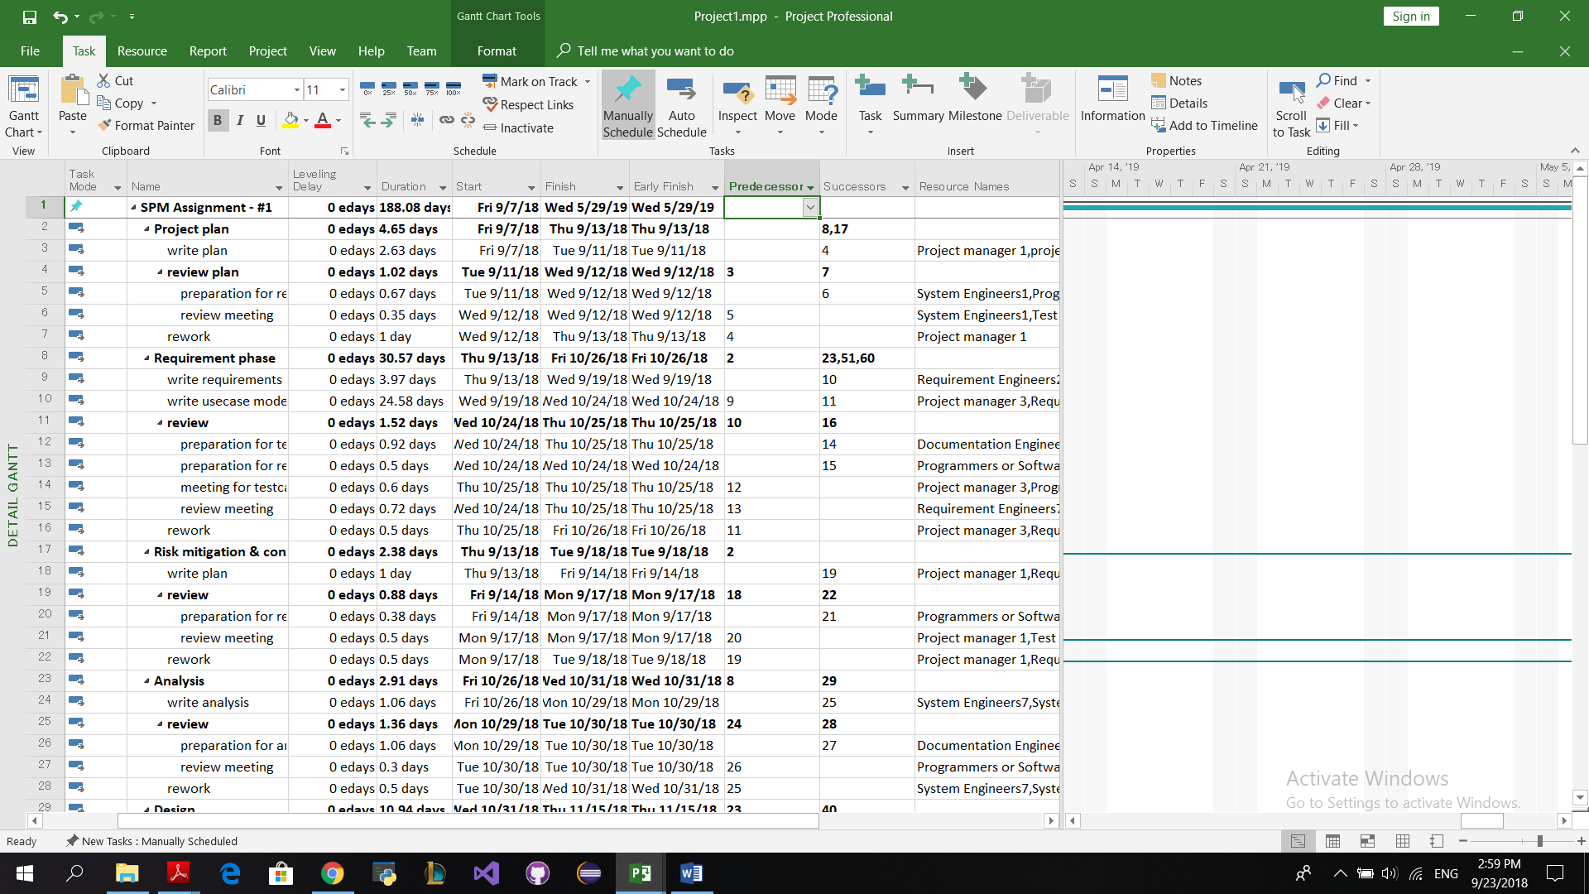

**Resource sheet**

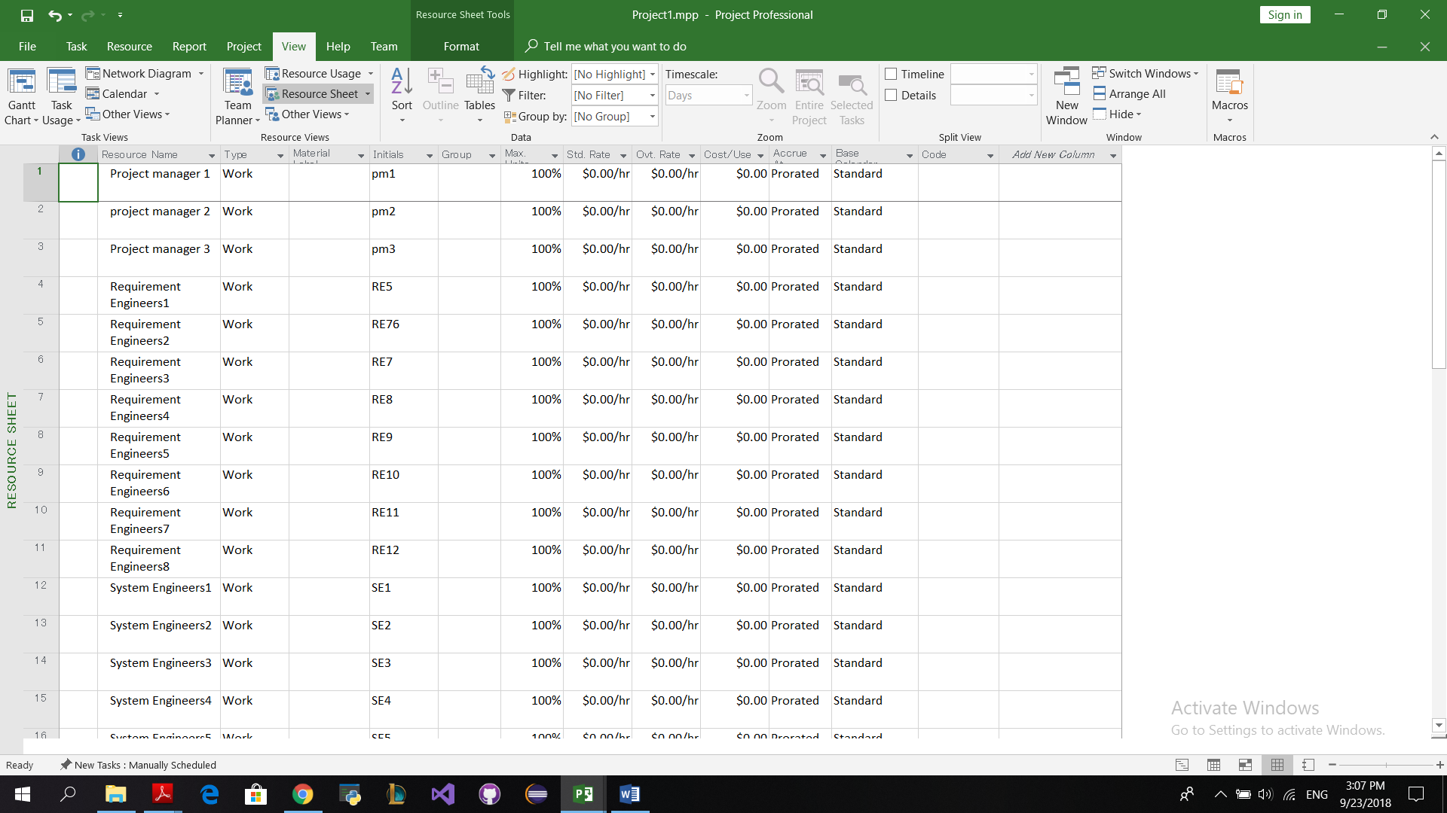

**CRITICAL PATH** – Detail Gantt chart

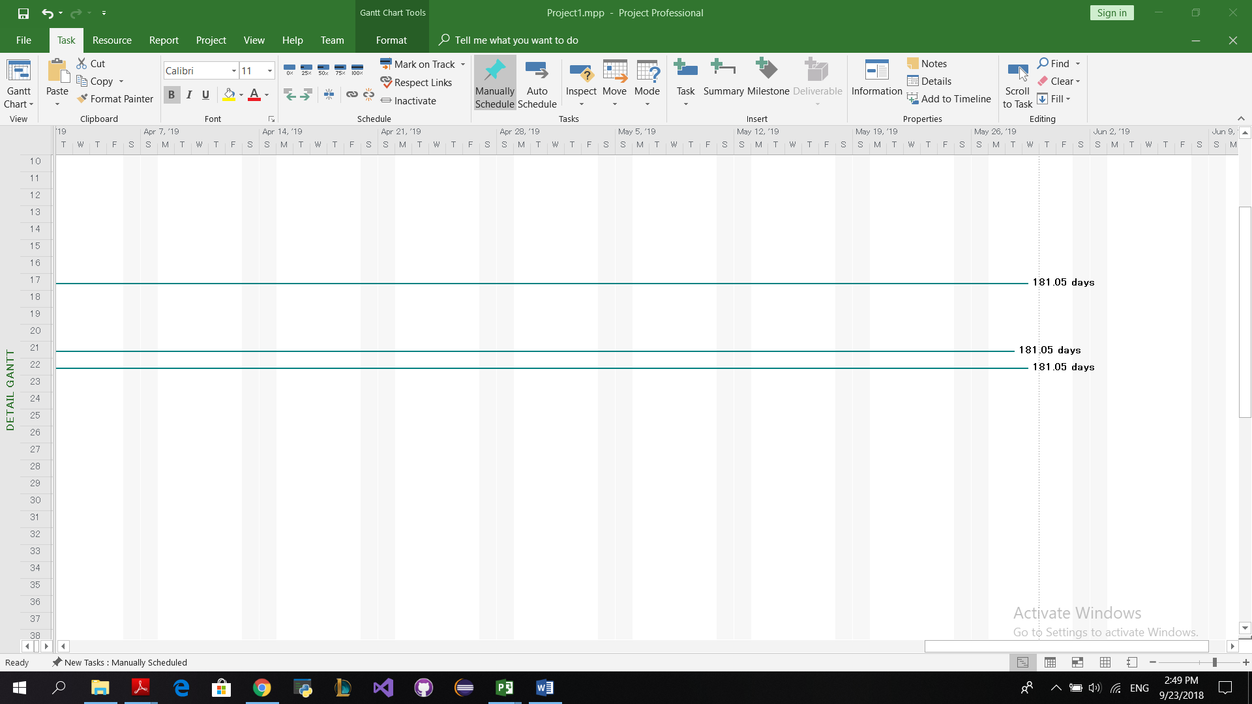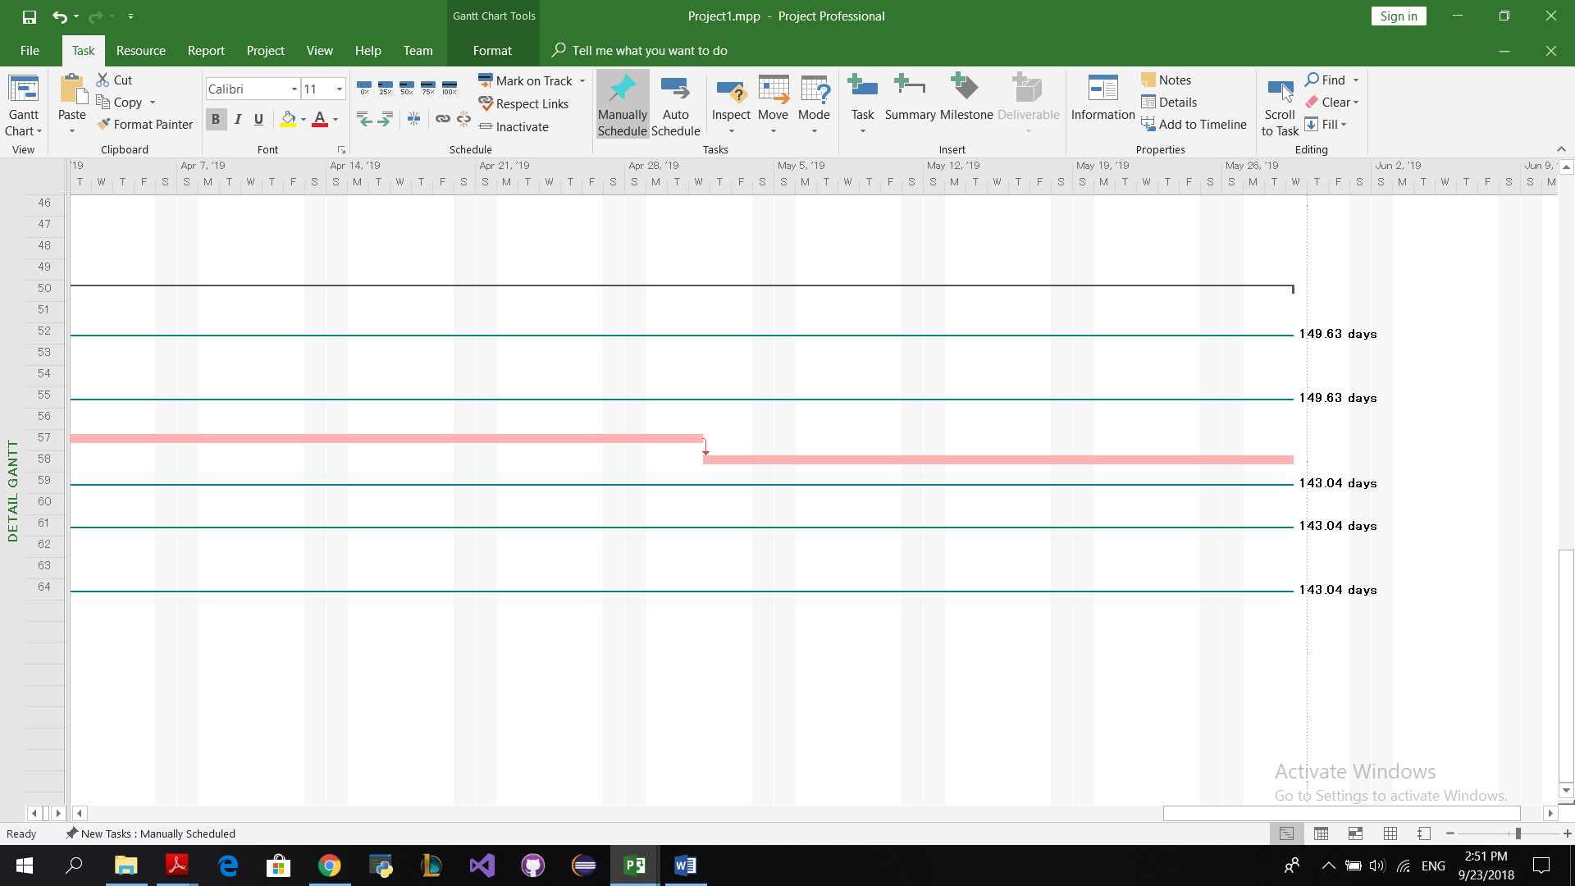

**25% - Resource utilization**

**Start – 9/7/2018 End date- 7/27/2021**

**DAYS – 752.8 Earliest finish – 7/27/2021**

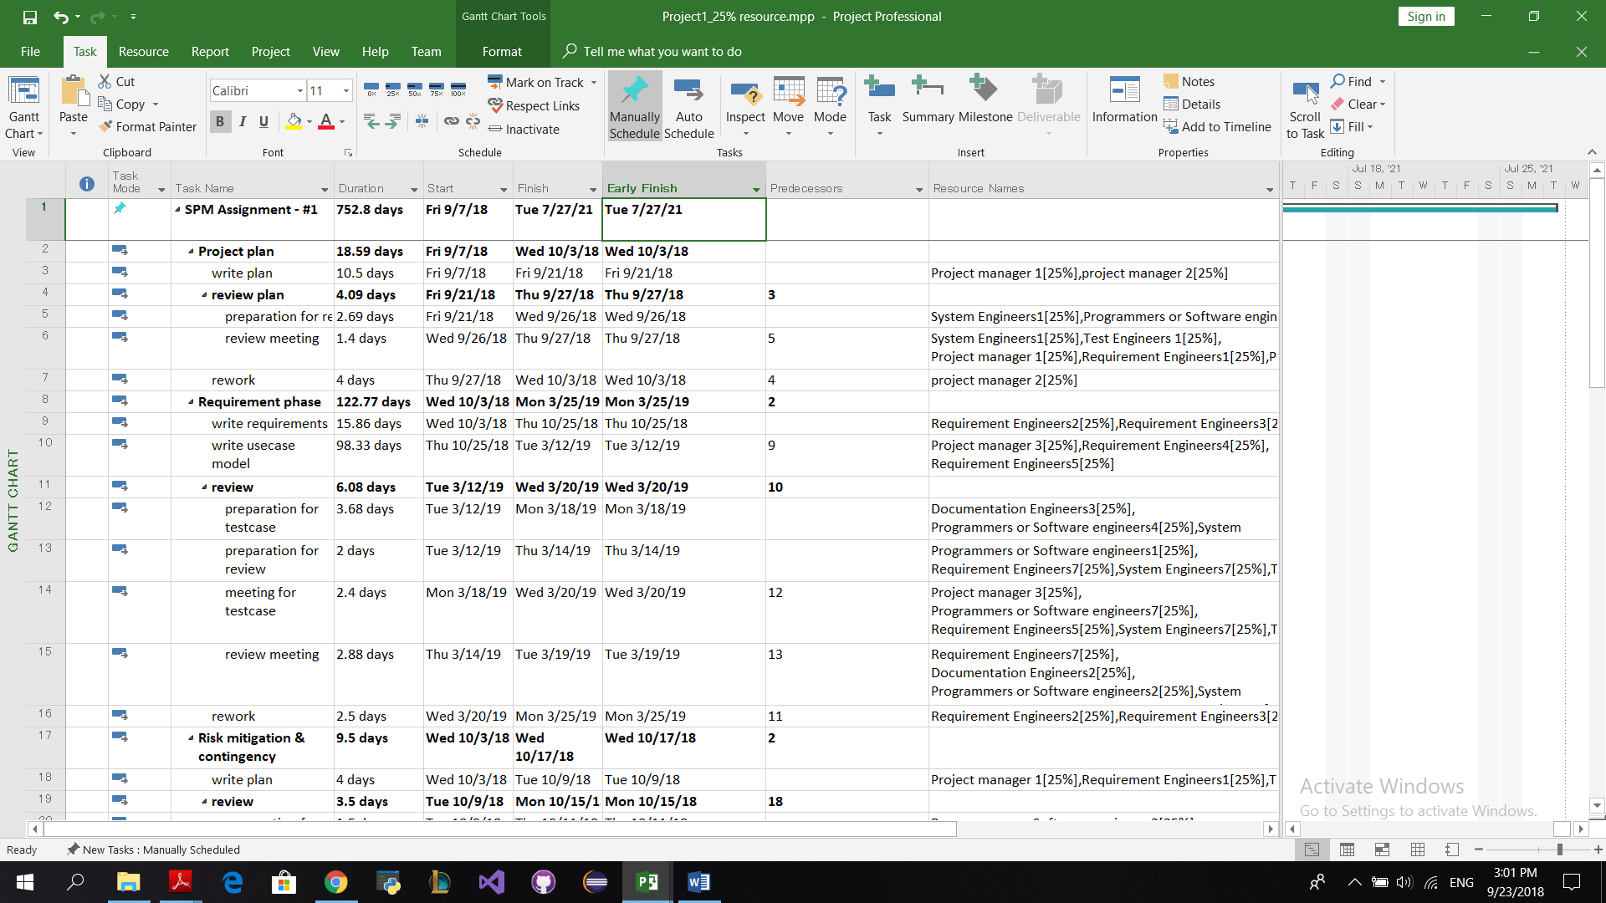

**Resource sheet**

